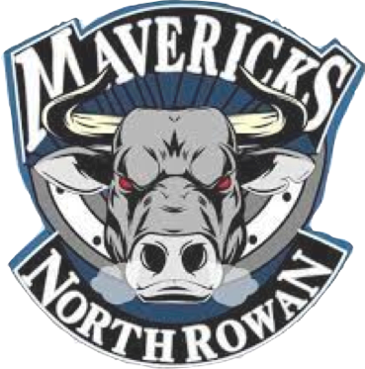
Contact: Madelyne Burris
District Instructional Technology Facilitator
North Rowan Middle School
O: 704-639-3018
Burrism@rss.k12.nc.us

News Release

FOR IMMEDIATE RELEASE
February 7, 2023

North Rowan Middle School FFA Poultry Judging CDE Team Impresses at Mock Competition

Shelby, NC – The North Rowan Middle School FFA Poultry Judging Career Development Event (CDE) Team had a successful and informative experience at the recent mock competition held at Cleveland Community College.

The students participated in a range of poultry-related activities, including judging the interior and exterior quality of eggs, further processed foods, ready-to-cook poultry carcasses, and identifying key cuts of meat. The team's impressive performance and professionalism showcased their hard work and dedication to the FFA program.

"We are extremely proud of our students for their outstanding performance at the mock competition," said Katie Dionne, FFA Advisor. "Their passion for the FFA and poultry industry shines through, and we know they will continue to make a positive impact in the future."

The North Rowan Middle School FFA Poultry Judging CDE Team will participate in the final State Poultry Competition on February 15th, where they will have the opportunity to showcase their skills against FFA members from across the state. The North Rowan Middle School FFA program is dedicated to developing students' leadership, personal growth, and career success through hands-on agricultural experiences. The program's mission is to make a positive difference in the lives of students and the communities they serve.

For more information about North Rowan Middle Schools’s FFA program, please contact our FFA Advisor Katie Dionne, DionneKL@rss.k12.nc.us

**Photo of students from left to right: Kevin Saunders 8th grade, Bri Miller, 6th Grade, Dionne Vilte, 8th Grade, Ashara Weatherwax, 8th Grade

